**CAKE WEBSITE:**

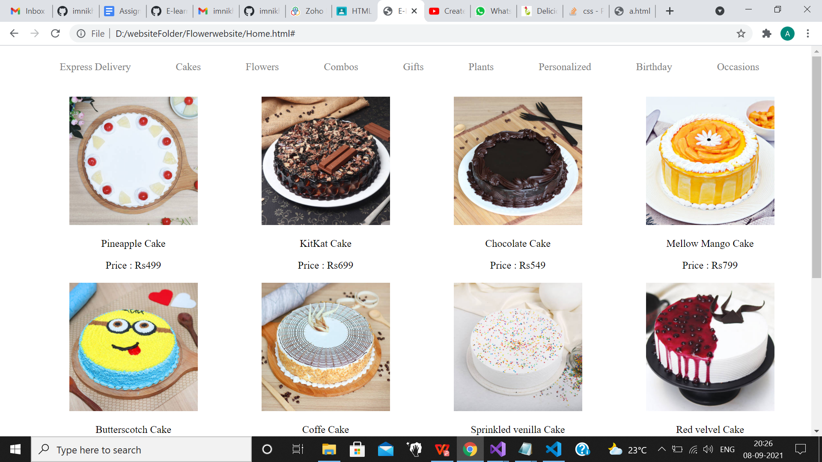

FOOTER :

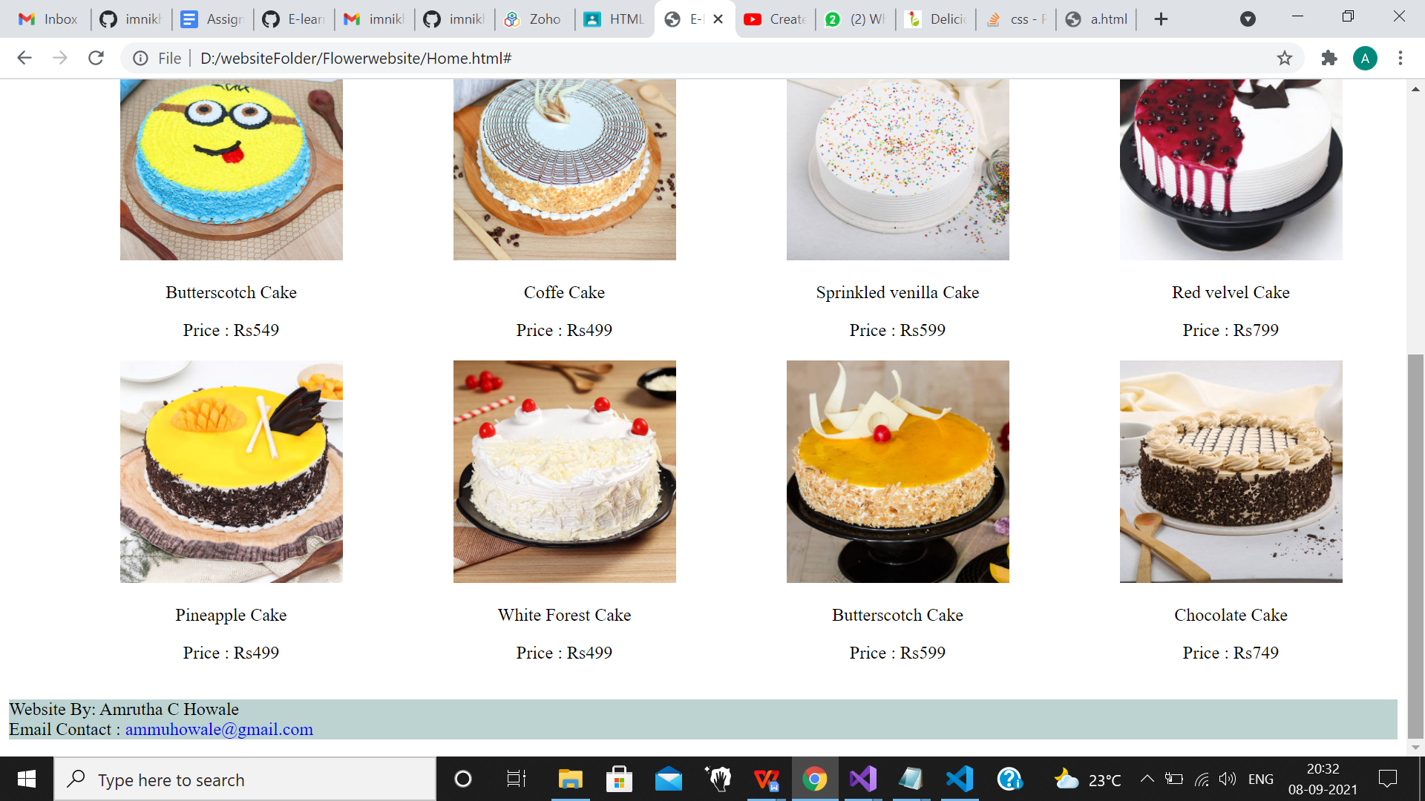

HOME.HTML

<!DOCTYPE html>

<html>

<head>

<meta charset="utf-8"/>

<title>E-Learning</title>

<meta http-equiv="X-UA-Compatible" content="IE=edge">

<meta http-equiv="width=device-width, initial-scale=1" name="Viewport"/>

</head>

<style>

a{

text-decoration: none;

}

li{

list-style: none;

}

.navbar{

display: flex;

flex-direction: row;

align-items: center;

padding: 0px 10px;

background-color:white;

}

nav ul {

display: flex;

flex-direction: row;

}

nav ul li{

margin-left: 5px;

margin-right: 5px;

}

nav ul li a{

color: gray;

display: block;

margin-left: 30px;

margin-right: 30px;

}

.cakedetails{

margin-top: 20px;

margin-left: 20px;

}

table, td, th

{

border-collapse: collapse;

text-align: center;

}

</style>

<body>

<div class="navbar">

<nav>

<ul>

<li><a href="#">Express Delivery</a></li>

<li><a href="#">Cakes</a></li>

<li><a href="#">Flowers</a</li>

<li><a href="#">Combos</a</li>

<li><a href="#">Gifts</a</li>

<li><a href="#">Plants</a></li>

<li><a href="#">Personalized</a></li>

<li><a href="#">Birthday</a></li>

<li><a href="#">Occasions</a></li>

</ul>

</nav>

</div>

<div class="cakedetails">

<table style="width: 100%;" class="caketable">

<div class="row1">

<tr>

<td>

<img src="Cake-01.jpg" width="200" height="200">

<p>Pineapple Cake</p>

<p>Price : Rs499</p>

</td>

<td>

<img src="cake2.jpg" width="200" height="200">

<p>KitKat Cake</p>

<p>Price : Rs699</p>

</td>

<td>

<img src="Cake3.jpg" width="200" height="200">

<p>Chocolate Cake</p>

<p>Price : Rs549</p>

</td>

<td>

<img src="Cake10.jpg" width="200" height="200">

<p>Mellow Mango Cake</p>

<p>Price : Rs799</p>

</td>

</tr>

</div>

<div>

<tr>

<td>

<img src="Cake4.jpg" width="200" height="200">

<p>Butterscotch Cake</p>

<p>Price : Rs549</p>

</td>

<td>

<img src="Cake5.jpg" width="200" height="200">

<p>Coffe Cake</p>

<p>Price : Rs499</p>

</td>

<td>

<img src="Cake6.jpg" width="200" height="200">

<p>Sprinkled venilla Cake</p>

<p>Price : Rs599</p>

</td>

<td>

<img src="Cake11.jpg" width="200" height="200">

<p>Red velvel Cake</p>

<p>Price : Rs799</p>

</td>

</tr>

</div>

<div>

<tr>

<td>

<img src="Cake7.jpg" width="200" height="200">

<p>Pineapple Cake</p>

<p>Price : Rs499</p>

</td>

<td>

<img src="Cake8.jpg" width="200" height="200">

<p>White Forest Cake</p>

<p>Price : Rs499</p>

</td>

<td>

<img src="Cake9.jpg" width="200" height="200">

<p>Butterscotch Cake</p>

<p>Price : Rs599</p>

</td>

<td>

<img src="Cake12.jpg" width="200" height="200">

<p>Chocolate Cake</p>

<p>Price : Rs749</p>

</td>

</tr>

</div>

</table>

</div>

<footer style="background-color: rgb(188, 211, 209);width: 100%;">

<p>Website By: Amrutha C Howale<br>

<a>Email Contact :</a>

<a href="ammuhowale@gmail.com">ammuhowale@gmail.com</a>

</p>

</footer>

</body>

</html>